Welding Lab

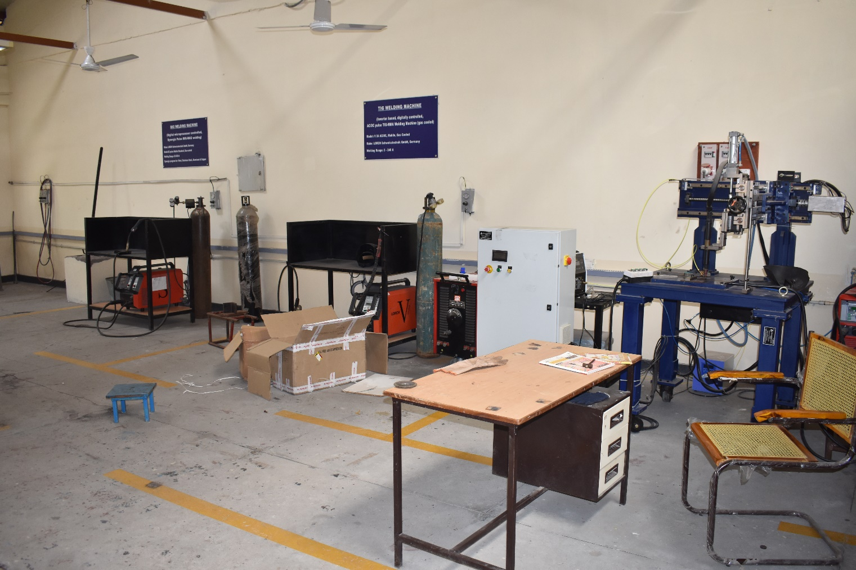

PLASMA PROFILE CUTTING MACHINE
Make: ADOR
Model: Kingcut Smarty
Specifications:
Machine overall width (without Cable Track) | 1600 mm Aprox
Rail length: | 3500 mm Aprox
Cutting width | 1500 mm
Cutting length | 3000 mm
Material to cut with OXY Fuel process: | Mild steel
Machine rapid speed: | 6000 mm/Min
Gas Required | Oxygen and Acetelene or LPG
Cutting Thickness by Plasma | Max 16 mm with Pierce 20 mm from Edge
Cutting Thickness by Gas | 5-150 mm
Programing accuracy | ± 0.1 mm
Repeatability Accuracy | ± 0.5 mm

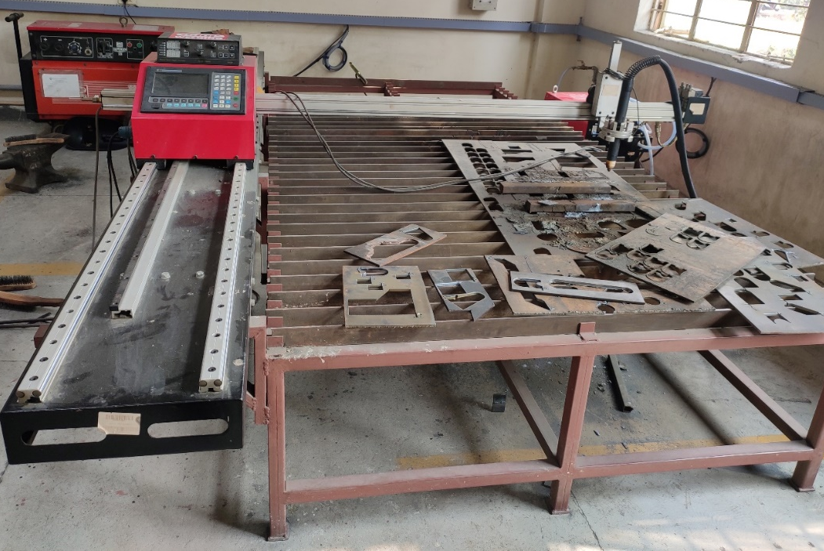

TIG WELDING MACHINE
(Inverter based, digitally controlled, AC/DC pulse TIG-MMA Welding Machine (gas cooled))
Model: V 24 AC/DC, Mobile, Gas Cooled
Make: LORCH Schweisstechnik GmbH, Germany
Welding Range: 3 - 240 A
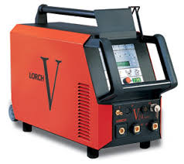

MIG WELDING MACHINE
(Digital microprocessor controlled, Synergic Pulse MIG-MAG welding)
Make: LORCH Schweisstechnik GmbH, Germany
Model: S3 pulse Mobile Standard, Gas-cooled
Welding Range: 25-320 A
Synergic program for: Steel, Stainless Steel, Aluminum & Copper

SPOT WELDING MACHINE
MAKE: GEMCO
Model:
Specifications:
Rating | 4 KVA
Main Supply | 230 V/50 Hz. Single Phase
Throat Depth | 125mm
- Weld ability in M.M.: M.S., S.S., Brass.
- Maximum Thickness x 2: 0.8, 0.5, 0.

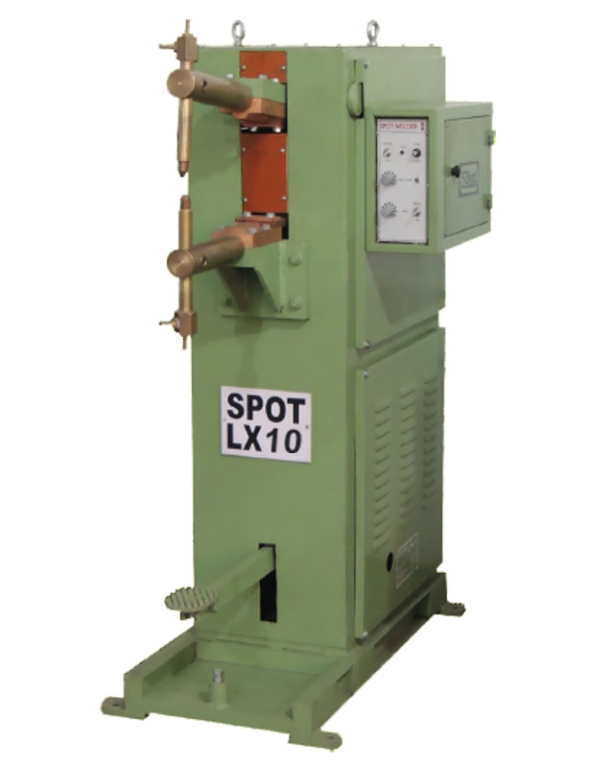
WELDING GENERATOR
Make: ADOR
Model: SUPERGEN 320
Specifications:
Supply voltage | 415 Volts
Phase | 3
Power | 15.5/20.78 Kw/HF
Open circuit voltage | 100 Volts
Welding current range | 35 – 320 Amps
Type of cooling | Forced Air

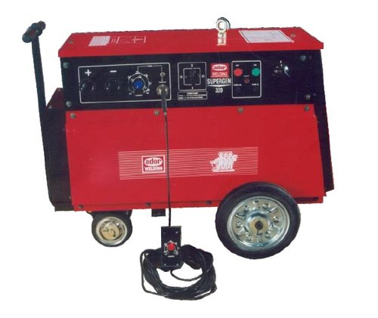
AC ARC WELDING TRANSFORMER(3 Nos)
Make: ADOR
Model: TPA 303
Specifications:
Supply voltage | 380/415 Volts
Phase | 3
Power | 16.5 KVA
Open circuit voltage | 66 Volts
Welding current range | 40-300 Amps
Type of cooling | Forced Air

