***********Title***********
SYNOPSIS

Submitted in partial fulfillment
of the requirements for the degree of
DOCTOR OF PHILOSOPHY
by
Candidate’s Name
202*PHXF****H

Under the Supervision of
Prof. ****** *****
and
Co-supervision of
Prof. ****** ******
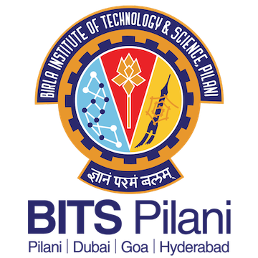
BIRLA INSTITUTE OF TECHNOLOGY & SCIENCE, PILANI
2024

Abstract
(Maximum 250 words)
Sed ut perspiciatis unde omnis iste natus error sit voluptatem accusantium doloremque laudantium, totam rem aperiam, eaque ipsa quae ab illo inventore veritatis et quasi architecto beatae vitae dicta sunt explicabo. Nemo enim ipsam voluptatem quia voluptas sit aspernatur aut odit aut fugit, sed quia consequuntur magni dolores eos qui ratione voluptatem sequi nesciunt. Neque porro quisquam est, qui dolorem ipsum quia dolor sit amet, consectetur, adipisci velit, sed quia non numquam eius modi tempora incidunt ut labore et dolore magnam aliquam quaerat voluptatem. Ut enim ad minima veniam, quis nostrum exercitationem ullam corporis suscipit laboriosam, nisi ut aliquid ex ea commodi consequatur? Quis autem vel eum iure reprehenderit qui in ea voluptate velit esse quam nihil molestiae consequatur, vel illum qui dolorem eum fugiat quo voluptas nulla pariatur.

- Introduction: (Brief introduction of the field, gap in the research, stating the research problem, etc.). This part can be written based on the introductory chapter of the thesis (Maximum two paragraphs or 1000 words)

- Chapter-wise brief description:
- Brief description of the proposed Chapter 2 (Maximum two paragraphs or 1000 words)
- Brief description of the proposed Chapter 3 (Maximum two paragraphs or 1000 words)
- Brief description of the proposed Chapter 3 (Maximum two paragraphs or 1000 words)
- ********

- Conclusion and/or summary (of the synopsis): This part can be written based on the concluding chapter of the thesis (Maximum two paragraphs or 1000 words)

Future directions/goals
- Short term goals: stating the immediate future direction of the Ph.D. research work (say, for the next two years). 1 paragraph or maximum 500 words.
- Long term goals: stating the long-term future direction of the Ph.D. research work (say, for the next five years). 1 paragraph or maximum 500 words.

Bibliography
(In standard format of the PhD thesis)

Research Outcomes
- Publications: (a) Published in peer reviewed journals; (b) Published in conference proceedings.

- Papers communicated: List of papers under review process

- Papers presented in conferences/symposia/….

- Information about patents

- List of conferences attended, presented posters, etc.

