Powder Metallurgy Lab

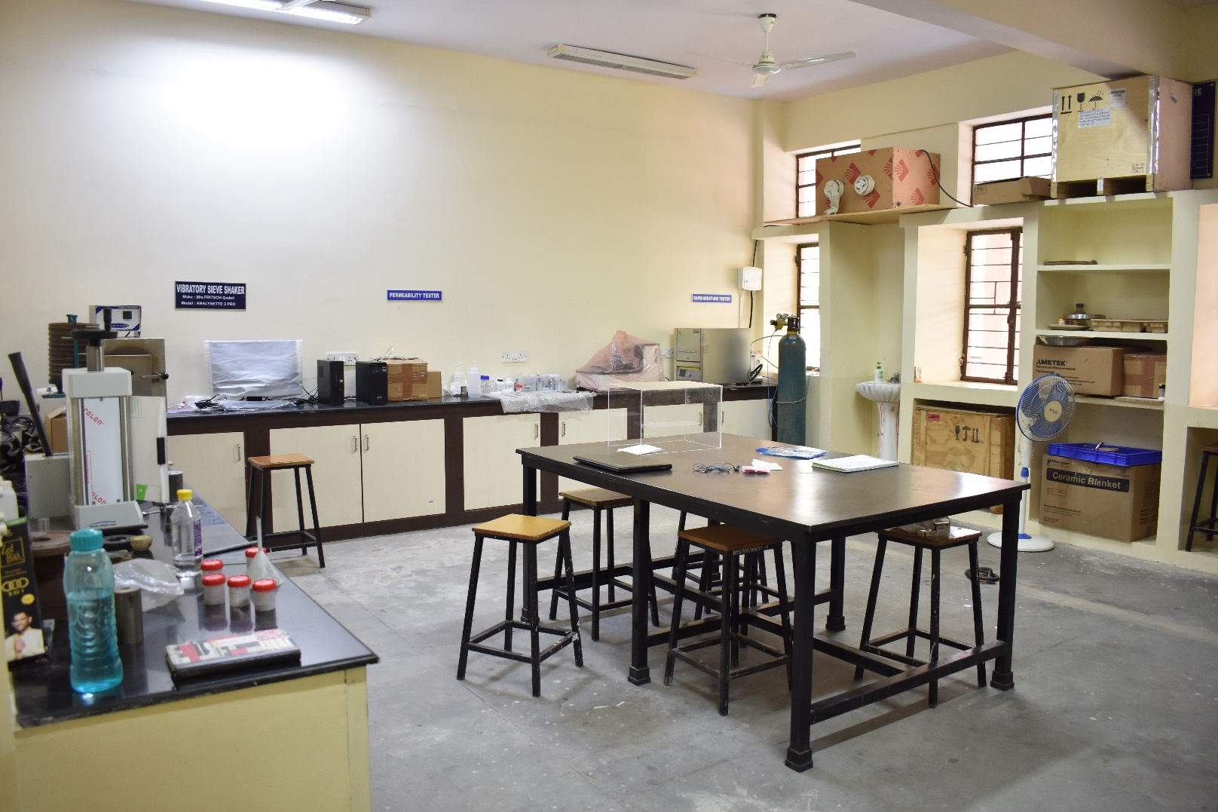

PLANETARY MICRO MILL

Model: PULVERISETTE 7(premium line)
Make: FRITSCH GmbH.
Specifications:
Application | Synthesis of micro, nano particles, mechanical alloying
Working Principle | Impact force
Grinding stations | 2 No’s
Grinding Bowls-Volume | 80 mL, 20 mL
Bowl and Balls-material | Tungsten Carbide
Grinding ball diameter | 0.6, 5, 10 mm
Max. feed size | 5 mm
Grinding conditions | Dry/wet/inert
RPM | Max. – 1100 ,Operation - 1000
Attachments | GTM, Wet process emptying device, counterweights, inert gas

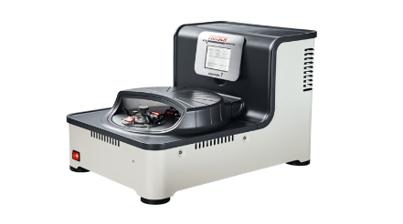
PELLET PRESS
Model: PP 25
Make: RETSCH
Specifications:
Application | Pressing pellets from powders
Feed Grain Size | <60 µm or <40 µm
Max. Capacity | 25 Ton
Operating capacity | 20 Ton
Pressure force | 10-250 kN
Die diameter | 32 mm
Attachment | Aluminum cups, free pressing

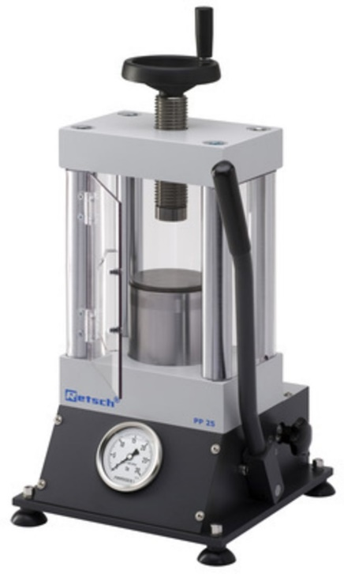
HIGH TEMPERATURE MUFFLE FURNACE
Make: NABERTHERM
Model: LHTC(T) 03/16
Specifications:
Application | Sintering of metals and ceramics
Max. temperature | 1600 °C
Working temperature | 1500 °C
Heating chamber dimensions | 120x210x120 mm
Heating elements | SiC rods
Features | Programable, retrieval of data, fresh air flap, exhaust pipe
Attachments | Rotameter, inert atmosphere

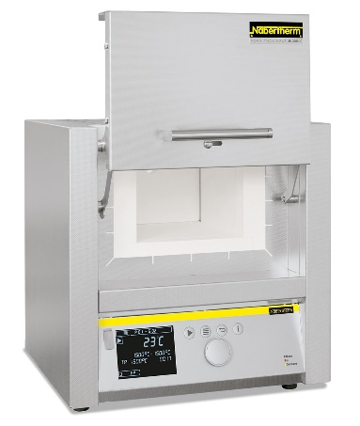
POTENTIOSTAT AND GALVANOSTAT
Make: Princeton Applied research
Model: VersaSTAT 3
Specifications:
Application | Energy Storage, Corrosion & Electrochemistry.
Voltage control (Potentiostat mode)
Applied voltage range | ± 10 V
Applied voltage accuracy | ±0.2% of value ± 2 mV
Current control (Galvanostat mode)
Applied current range | ± 2 A
Minimum current range / resolution | ± 200 nA / 60 pA
Impedance (EIS)
Mode | Potentiostatic / Galvanostatic
Frequency range | 1 MHz
Software | VersaStudio
Attachments | Corrosion cell, platinum, calomel, Ag/AgCl reference electrodes.
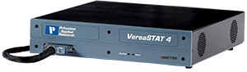

WEIGHING BALANCE

Model : Quintix 6102 -10IN

Make : Sartorius
Specifications:
Weighing Capacity | 6100 g
Readability | 10 mg
Repeatability | 10 mg
Linearity Deviation | 20 mg
Weighing Pan Size | Ø180 mm

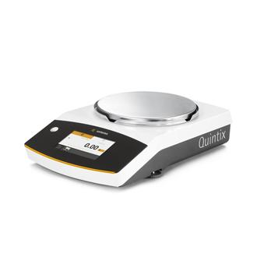
MUFFLE FURNACE
(With PID Controller & Digital Timer)

Model : MSI – 73

Make : META Lab

Specifications:

Temp. Range | 1200ºc
Working Temp. | 1150ºc
Accuracy | +/- 1% FSD
Power Rating | 3.5 K.W
Size | 12"X6"X6"

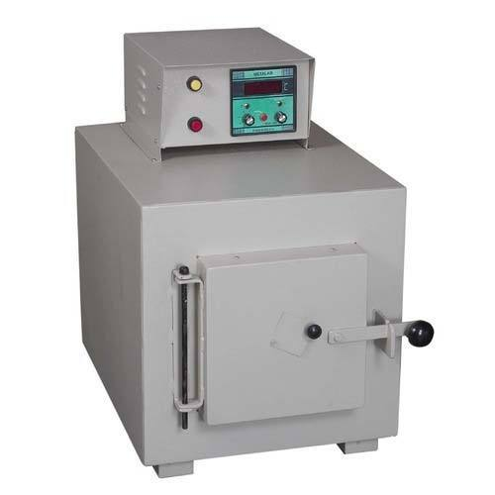

VIBRATORY SIEVE SHAKER

Make : M/s. FRITSCH GmbH

Model: ANALYSETTE 3 PRO
Specifications:
Method of analysis | sieving
Sieving action | two-dimensional
Dry sieving
Measuring range | 20 µm - 63 mm*
Max. sample quantity approx | for sieves < 63mm:upto 2 kg* for sieves < 100 µm: up to 100 g*
Sieving time approx. | 3 - 20 min*
Wet sieving
Measuring range | 20 µm - 10 mm
Max. sample quantity approx. | 20 - 100 g*
Sieving time approx. | 30 - 60 min*
Further details
Sieve diameters | 100 mm, 200 mm or 8"
Max. number of sieves per sieve stack | 10 (50 mm height), 16 (25 mm height)
Max. weight of sieve stack | 3 kg
Max. height of sieve stack | 550 mm
Amplitude | 0.1 - 3 mm

