**Metrology Lab**

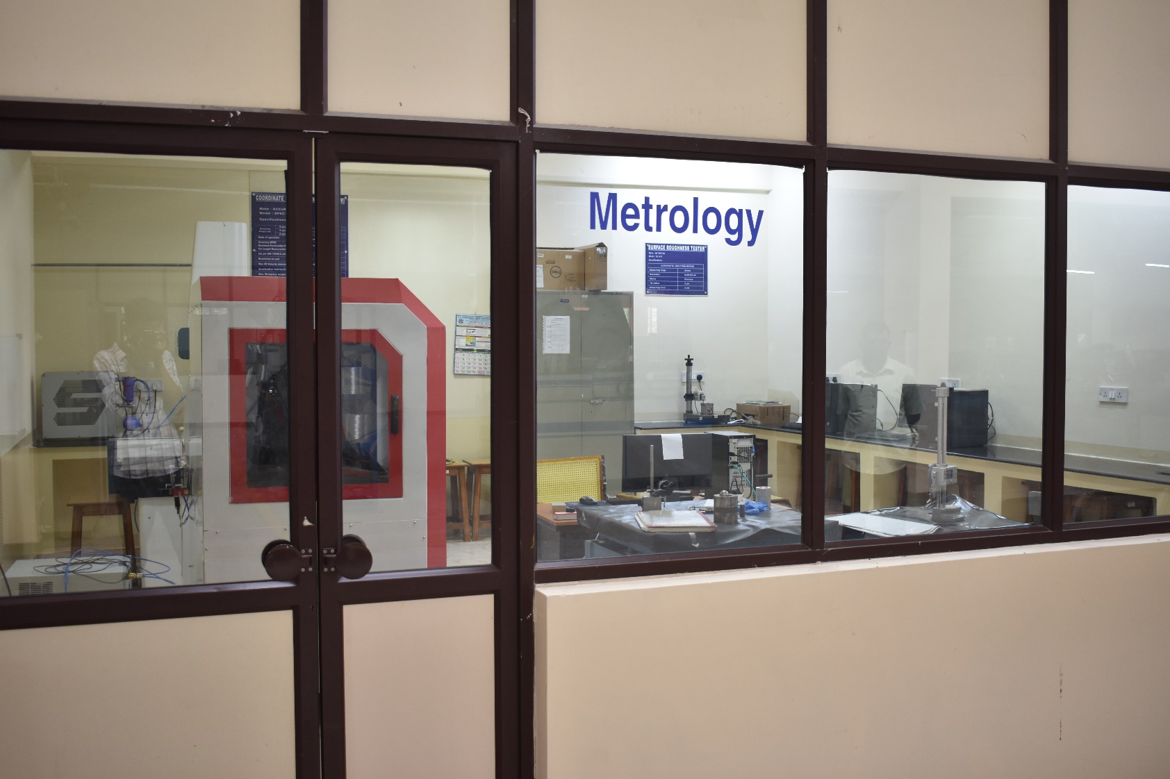

**COORDINATE MEASURING MACHINE(CMM)**

**Make** : Accurate India.

**Model** : Spectra

**Specifications**:

|  |  |  |
| --- | --- | --- |
| Measuring range( mm) | X axis | 500mm |
| Y axis | 600mm |
| Z axis | 400mm |
| Mode of operation | | Motorised / CNC |
| Accuracy MPEE Maximum Permissible Error For Length Measurement  (As per ISO 10360-2 with TP 200 in µm) | | 2.2+L / 350 |
| Resolution (in µm) | | 0.1 / 0.5 |
| Max 3D Velocity (mm/sec) | | 900 |
| Acceleration (mm/sec2) | | 1200 |
| Max. Workpiece weight (kg) | | 250 |
| System Weight (kg) | | 890 |
| Guidance | | Air Bearings on all axes |
| Measuring table (Material) | | Granite |
| Probing Option | | TP 20, TP200, SP 25M, Revo, Apollo, laser scanner |
| Probe heads | | MH8, MIH, PH 10, PH 20 |

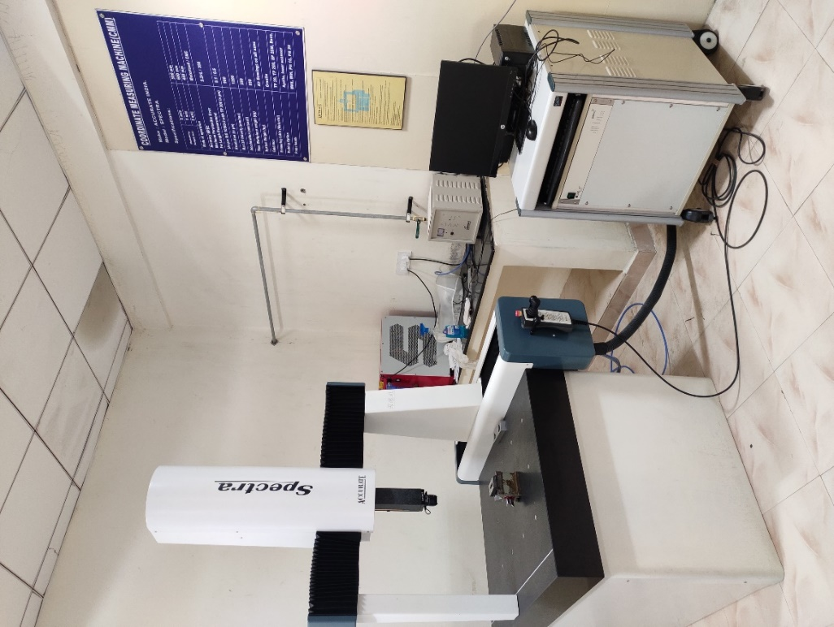

**SURFACE ROUGHNESS TESTER**

**Make** : Mitutoyo

**Model**  : SJ 410

**Specifications**:

|  |  |
| --- | --- |
| Differential Induction Method | |
|  |  |
| Measuring range | 25 mm |
| Resolution | 0.000125 µm |
| Stylus | Dimond |
| Tip radius | 5 µm |
| Measuring force | 4 mN |



**VISION MEASURING MACHINE**

**Make** : Mitutoyo

**Model** : Quick Scope--L2010Z/AFC

**Specifications**:

|  |  |  |
| --- | --- | --- |
| XYZ Measuring volume | | 200 x 100 x 150 mm |
| Resolution/Scale type | | 0.1 μm / Linear encoder |
| Drive method | | X / Y axis: manual, Z axis: CNC with Auto focus |
| Accuracy | X-axis | (2.2+0.02L) µm, L in mm |
| Y-axis | (4.5+0.006L) µm, L in mm |
| Image Sensor | | 3 mega pixel CMOS colour Camera |
| Observation unit | | 8-step zoom lens; total magnification: 29X to 202X |
| Illumination | Transmitted light | White LED |
| Co-axial light | White LED |
| Ring light | 4 – quadrant ring light(LED) |
| Maximum stage loading | | 10 kg |

