Metal Forming Lab

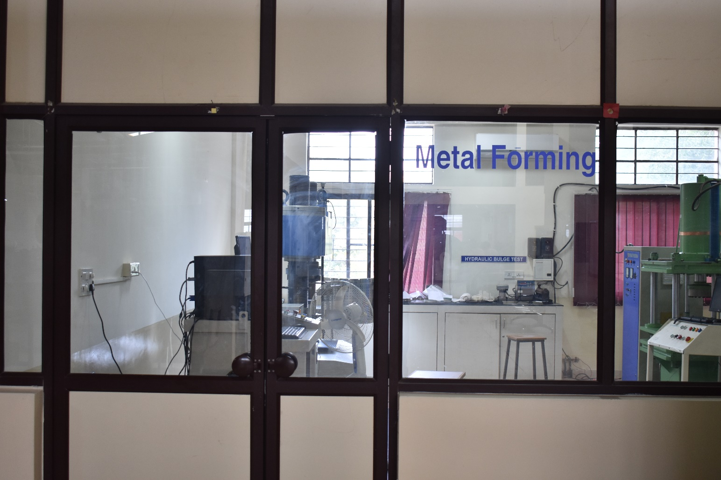

HYDRAULIC PRESS (Deep Drawing Test Setup)
Make: J. RAGRAU INSTRUMENTS
Specifications:
Capacity | 40T
Usable range | 35T
Displacement | 500 mm
Stroke length | 400 mm
Holding pressure | Up to 50 bar
Working pressure | Up to 100 bar
Daylight | 600 mm
Working area | 600 x 600 mm
Power pack motor | 7.5 h.p
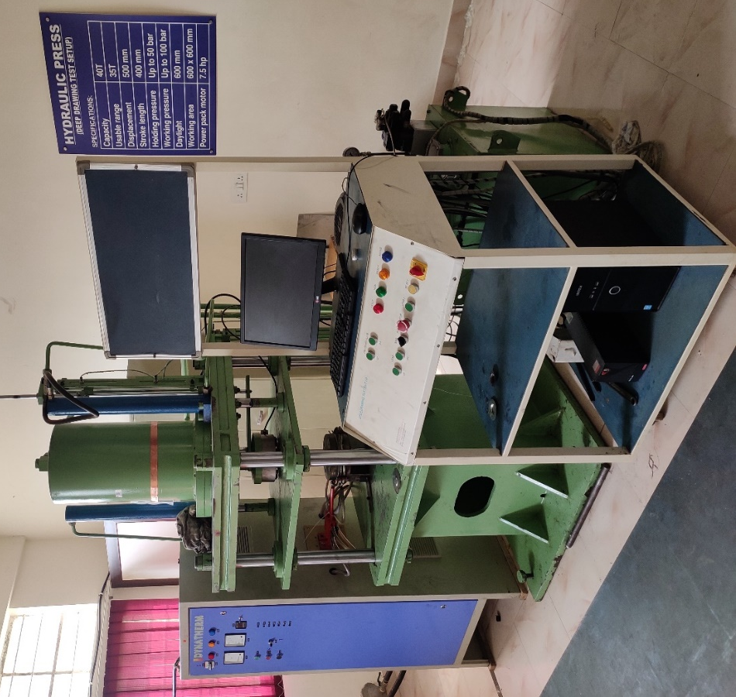

HYDRAULIC COMPRESSION TESTING MACHINE

Make : HEICO
Model : 2000kN

Specifications:
Capacity | 2000 kN
Vertical Clearance | 800mm
Travel of the Ram | 100mm
Platen Size | 250 mm square
HYDRAULIC POWER PACK
Flow of the pump | 10LPM
Motor capacity | 5 H.P.
Capacity of the tank | 100litres
Operating pressure | 200 Bars
Noise Level | Less than 70dB

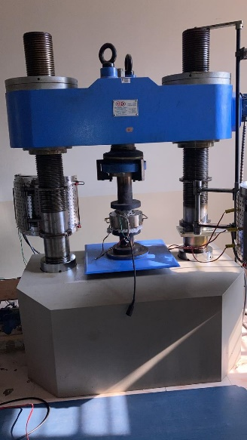
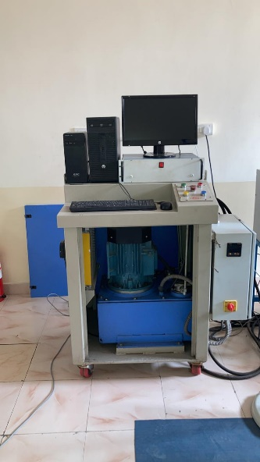

DIGITAL HAND OPERATED BULGE TESTING SYSTEM

Make : J. RAGRAU INSTRUMENTS

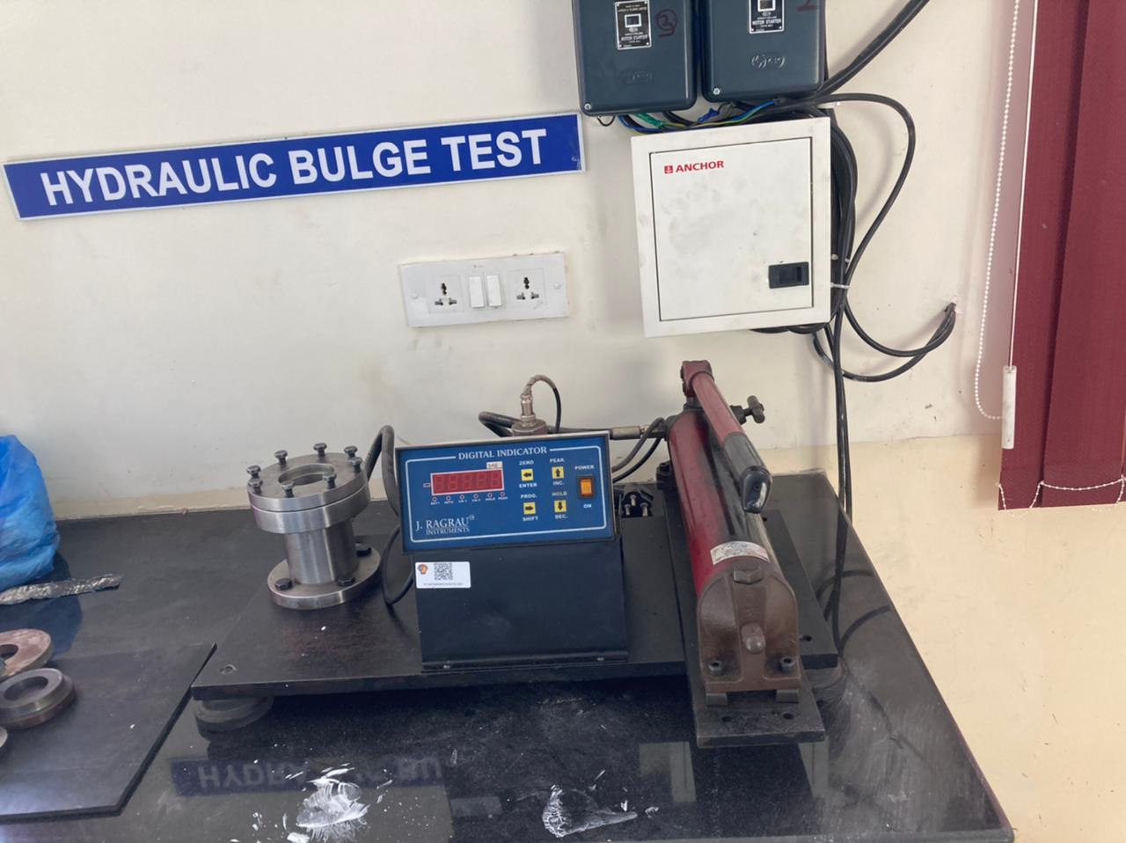

SHEARING MACHINE
MAKE : VIVEK
MODEL : VUS 7
Specifications :
Cutting Capacity (MS) Length x Thickness | 1525 X 4 mm
Stroke per minute | 50
Table height | 800 mm
Table width | 400 mm
Front gauge | 600 mm
Rear gauge | 750 mm
Blade length x width x thickness | 1525x63x18 mm
Motor capacity | 3.7kW

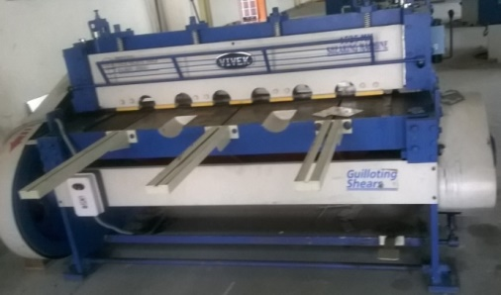
MECHANICAL PRESS
MAKE : VIVEK
MODEL : VPP – 3 (C-Type)
Specifications:

Capacity | 30 Ton
Stroke adjustment | 63 mm
Length and width bed | 522X381 mm
Distance bed to ram | 254 mm
Stroke per min. (s.g.) | 45
Stroke per min. (d.g.) | 40
Floor to top of bed | 890 mm
Motor capacity | 2.2 kW

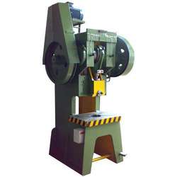

Hydraulic Deep Drawing Press (200 TON)
with SCADA Software
Make: Flowmech.
Year:2023
Specifications:
Type of the press | Pillar type (Down Stroke)
Total capacity of the press | 200 + 60 TON
Main ram capacity | 200 TON
Blank holder ram capacity | 60 TON
Main cylinder stroke | 700 mm
Blank holder ram stroke | 400 mm
Day light gap from main cylinder | 1200 mm
Bed size | 1000 X 1000 mm
Approaching speed | 4-5 mm/s
Punch speed | 0.1 – 1 mm/s
Return speed | 5-6 mm/s
T-slots size | T-20
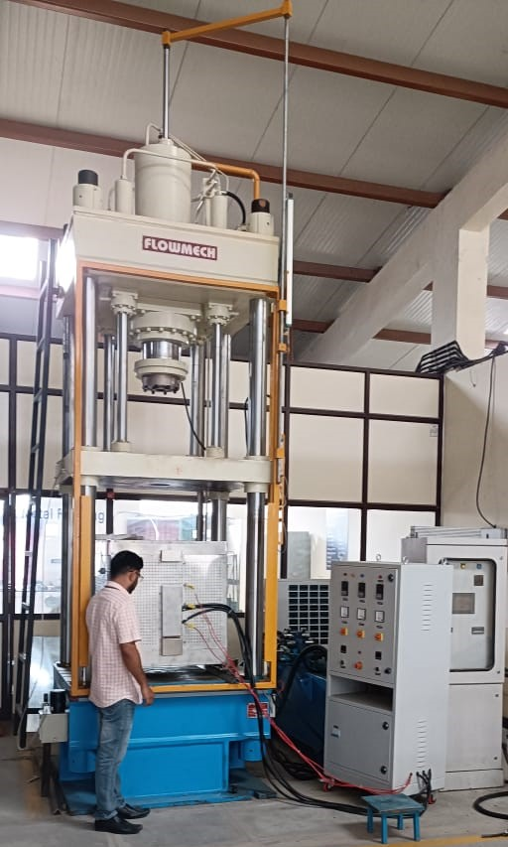

Three Zone Spilt Furnace
Make: Karthik Instrumentation
Year:2023
Specifications:

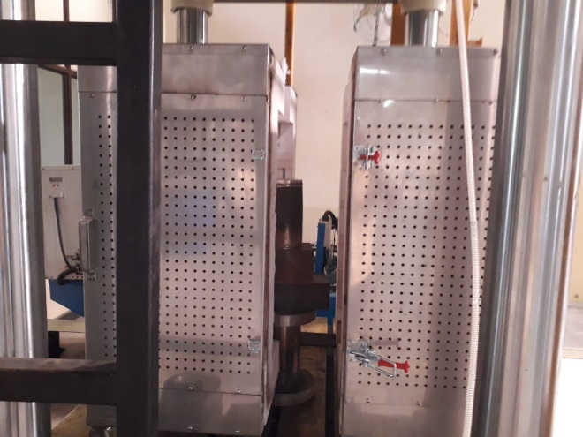

Heating Chamber | 500 x 600 mm (Diameter x Height)
Outer Dimension | 800 x 800 x 740mm (Length x Width x height)
Power Rating | 25 kW
Operating Temp Max. | 1000ºC
Rate of Heating | 900ºC within 90 minutes
Uniformity | 4°C on stable Ideal conditions
Power supply | 440 VAC, 40 Amps per phase
Sensor | Type ‘K’ Mineral insulated Thermocouple

