Machining Shop
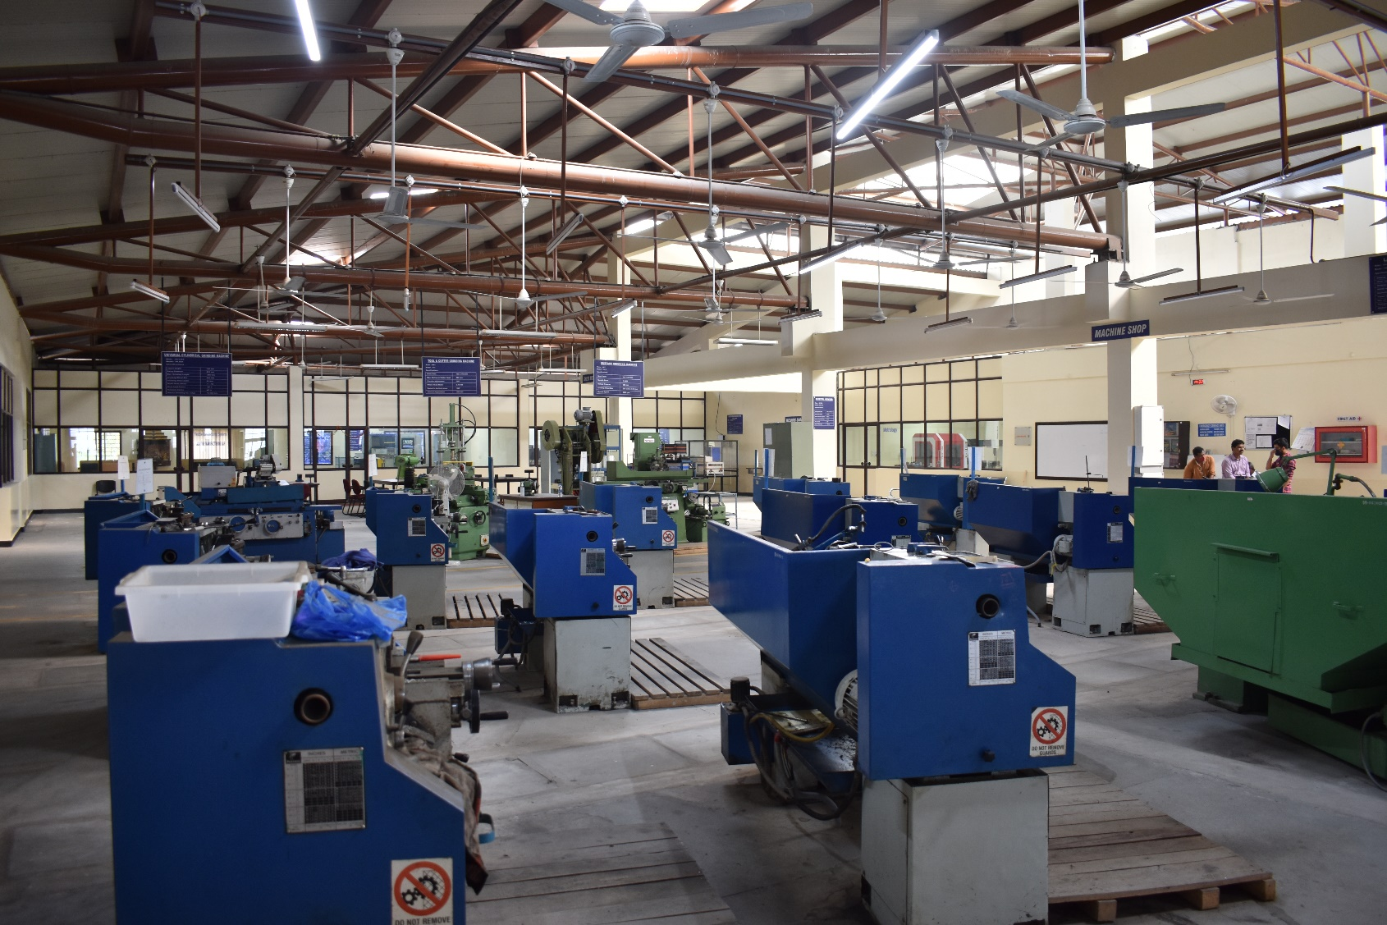

UNIVERSAL MILLING MACHINE
Model: UF 2
Make: BFW

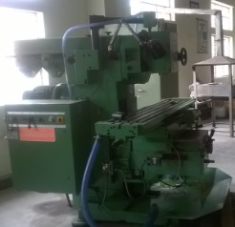
Specifications:

Longitudinal movement
Automatic | 800 mm
Manual | 830 mm

Transverse movement
Automatic | 230 mm
Manual | 260 mm
Spindle taper | ISO 40
Speed range | 45 – 2000 rpm
Clamping area | 1350 mm x 315 mm
T-slot / width / CD | 3 Nos/14 mm/63 mm

Feeds:

Longitudinal | 16 – 800 mm/min
Cross | 16 – 800 mm/min
Vertical | 4 – 200 mm/min
Swivel range of table to both sides | 45°
Milling spindle Motor | 5.5 kW
Feed Motor | 1.5 kW
Maximum safe load on table | 400 kg

HORIZONTAL / VERTICAL MILLING MACHINE

Make : BATLIBOI
Model : BFH-5
Specifications :

Longitudinal movement
Automatic | 810 mm
Manual | 810 mm

Transverse movement
Automatic | 275 mm
Manual | 280 mm
Spindle taper | ISO 40
Speed range | 45 – 2000 rpm
Clamping area | 1350 mm x 320 mm
T-slot / width / CD | 3 Nos /14 mm / 63 mm

Feeds:

Longitudinal | 14 – 900 mm/min
Vertical | 4 – 250 mm/min
Cross | 14 – 900 mm/min
Milling spindle Motor | 5.5 kW
Feed Motor | 1.5 kW
Maximum safe load on table | 275 kg
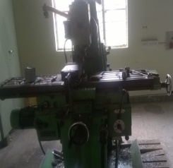

SHAPING MACHINE
Make : SAGAR
Model : SM 18 “
Specifications :
Stroke length | 18 “
Working surface of table | 407mm X 292mm
Maximum size of tool shank | 32mmX16mm
Range of ram speeds (Stroke Per Minute) | 17,25,50,75
Motor Capacity & Speed | 1.5KW &960rpm
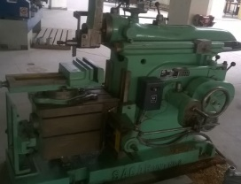

VERTICAL SLOTTING MACHINE
Make : Daljith
Model : DS –10
Specifications :
Stroke | 10’’
Rotary table | 15’’
Longitudinal movement | 12’’
Cross movement | 10’’
Cutting Speed of RAM (Per Minute) | 40x60
RAM Adjustment | 12’’
Throat Depth | 11’’
Distance from the Tool to the Main Column | 14’’
Motor Capacity | 1.5kw
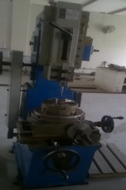

HIGH SPEED PRECISION LATHE MACHINE

Make : HMT Ltd

Model : NH26/1500

Specifications:
Height of centres | 260 mm
Dist. between centres | 1500 mm
Swing over bed | 575 mm
Swing over cross slide | 350 mm
Spindle Nose/Bore | A2-6/53 mm
Feed range (longitudinal) | 0.04 – 2.4mm/rev
Feed range (cross) | 0.02 – 1.2mm/rev
Spindle speed range | 40 – 2040rpm
Spindle power | 11KW
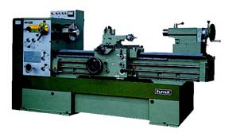
RADIAL DRILLING MACHINE

Make: Batlibai

Model: BVR 3

Specifications:
Max.drilling diameter in Steel | 32 mm
Max.drilling diameter CI | 35 mm
Drilling Radius max / min | 930 / 340 mm
Vertical Traverse of Arm | 520 mm
Horizontal Movement of Drill Head | 590 mm
Drilling Motor Power | 1.5 kw

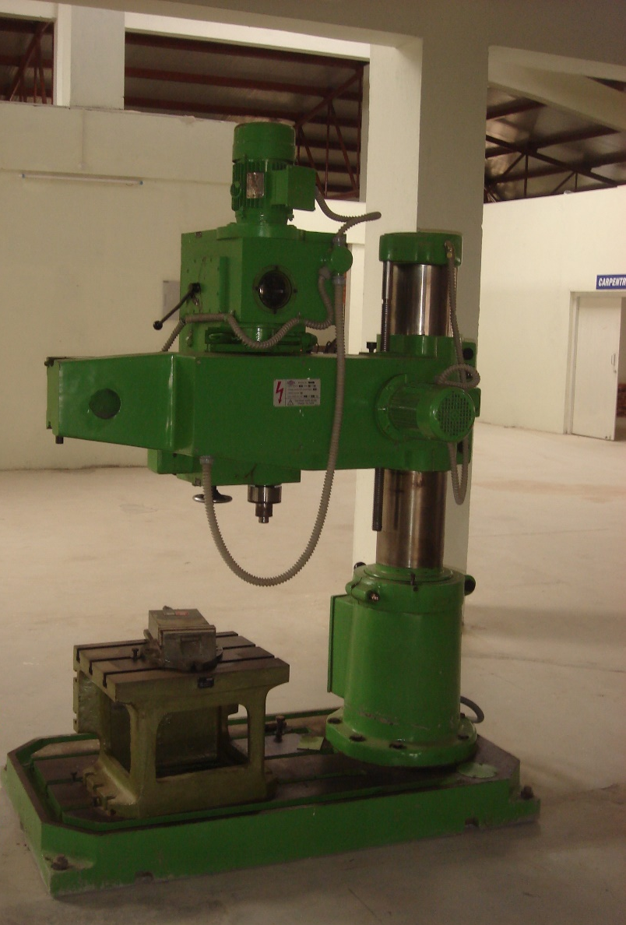

LATHE MACHINE (7NOS)

Make: Gujarat Lathe Manufacturing Co. Pvt. Ltd

Model: PANTHER 1350 / 1 Series

Specifications:
Swing | 335 mm
Dist. between centres | 540 mm
Swing over slide | 200 mm
Slide movement | 210 mm
Spindle Bore | 42 mm
Taper bore in center sleeve | MT 4
No. of speeds  Range / RPM | 8  45-938
Motor capacity | 1.5 kW

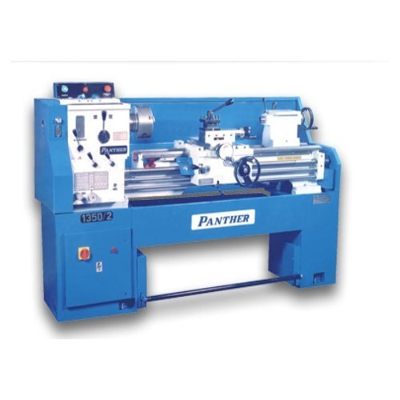

LATHE MACHINE(2NOS)

Make: Gujarat Lathe Manufacturing Co. Pvt. Ltd

Model: PANTHER 1650 / 1 Series

Specifications:

Swing | 410 mm
Dist. Between Centres | 1000 mm
Swing over Slide | 250 mm
Slide Movement | 250 mm
Spindle Bore | 42 mm
Taper Bore in Center Sleeve | MT 4
No. of Speeds  Range / RPM | 8  45-938
Motor capacity | 2.2 kW

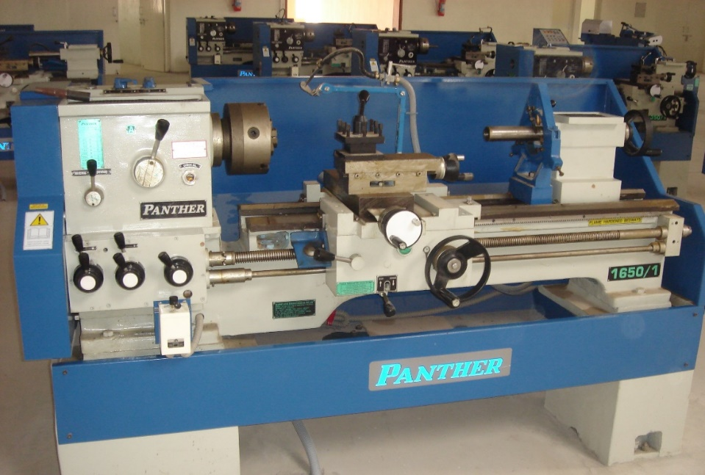

SURFACE GRINDING MACHINE
Make: HMT Machine Tools Limited

Model: 452 P
Specifications :

Work Table | 625 x 220 mm
Spindle Motor | 1.5 kW
Vertical Traverse | 280 mm
Grinding Wheel Size | 200x20x31.75 mm
Spindle Speed | 2800 rpm

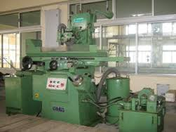

UNIVERSAL TOOL & CUTTER GRINDING MACHINE
Make: HMT Machine Tools Limited

Model: 411

Specifications:

Work Area | 750X 110 mm
Max. Swing on Cutter Head | 305 mm
Circular adjustment | 360°
Wheel Head Motor | 0.75 kW
Swivel in Vertical plane | 180°
Vertical Adjustment | 200 mm

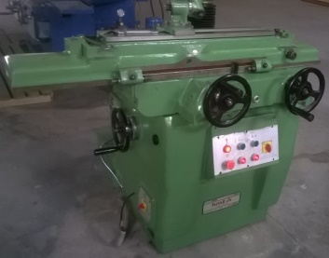

UNIVERSAL CYLINDRICAL GRINDING MACHINE

Make: HI-LIFE MACHINE TOOLS LIMITED

Model: HL 500

Specifications:

Centre Height | 150 mm
Swing Diameter | 295 mm
Max. Grinding Length | 500 mm
Grinding Wheel Dia. | 400 mm
Grinding wheel width | 40 mm
Wheel Head Swivel | + / - 60 °
Work head Centre | MT 5
Tailstock Centre | MT 4
Internal Grinding dia. range | 15-100 mm

PEDESTAL GRINDER

Make : EIFCO Machine Tools (P) Ltd

Model : MG 12

Specifications:

Size of grinding wheel | 300 x 40 x 50.8 mm
Wheel Centre distance | 645 mm
Base to centre line of spindle | 860 mm
Diameter of spindle bearings | 35 mm
Power of motor | 2 HP
Speed of Motor (rpm) | 1400 rpm
RPM of Grinding Wheels | 1910 rpm
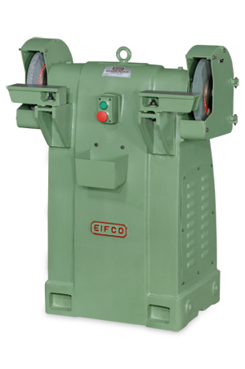

POWER HACKSAW

Make: EIFCO Machine Tools (P) Ltd

Model: HP 300

Specifications:

Max. Diameter | 300 mm
Max. Square | 250 mm
Stroke length (non adjustable) | 160 mm
No. of speed strokes | 3
Range of speed strokes (per minute) | 80 - 100 - 125
Blade Size | 525 X 45 X 2.25 mm
Power of main motor | 1.5 kW
Power of coolant motor | 0.09 kW
