Foundry Lab

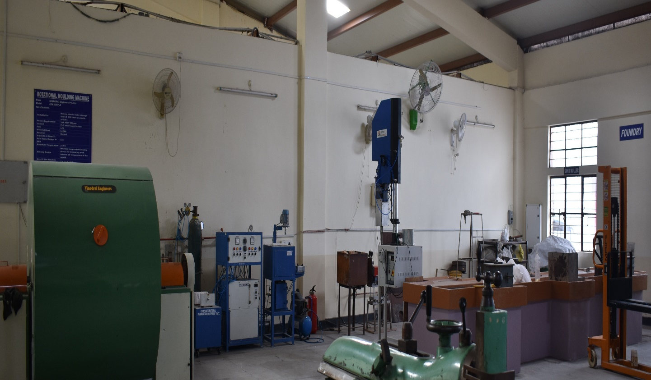

MAGNESIUM METAL STIR CASTING FURNACE

Make: VB Ceramics

Model: VBCC / MM-SCF / 1000°C

Specifications:
CRUCIBEL VOLUME | 200mm Di. X 300mm
Operating TEMPERATURE | 1000°C (Max. 1100°C)
THERMOCOUPLE | K – Type (225mm long) with 1°C accuracy
POWER | 4KW – SINGLE PHASE/AC/230V
Furnace Actual Current Rating | 15 Amps (Max)
Stirrer Motor Capacity and Speed | AC motor with 0.25HP and 1400rpm
Die material | Cast Iron

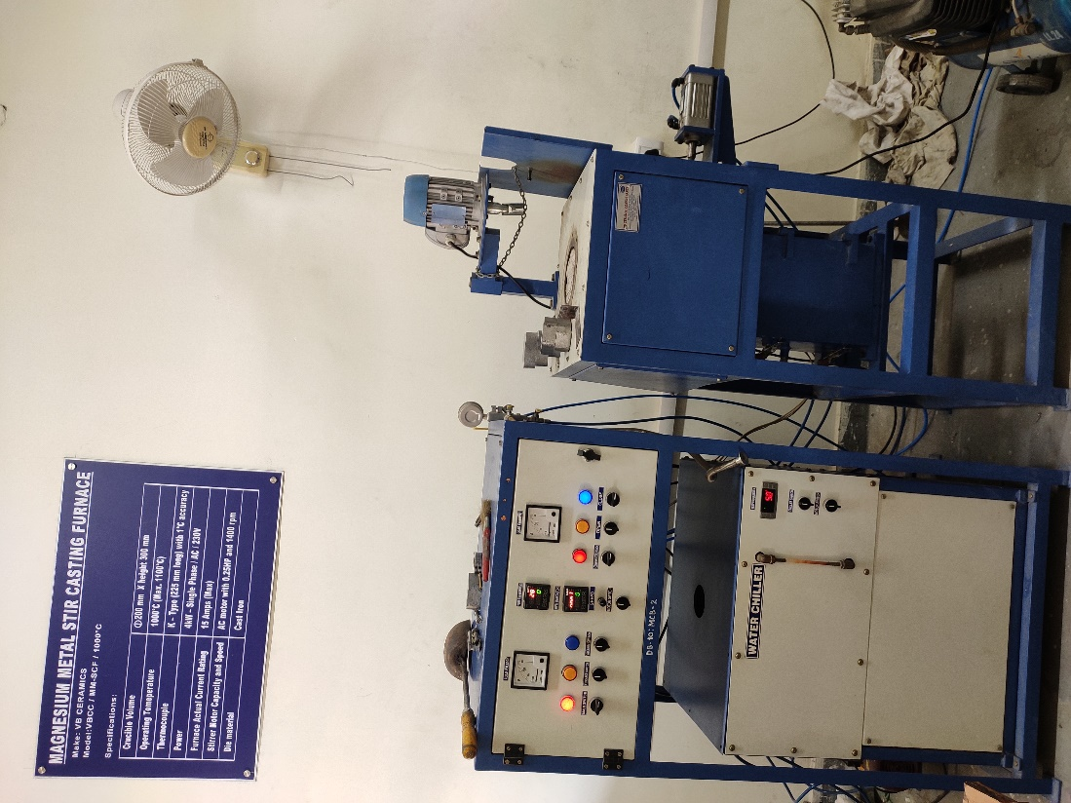

COMPOSITE MATERIALS FABRICATION EQUIPMENT

Make: VB Ceramics

Specifications:

Mould Volume | Dia. 50 mm X height 150 mm
Operating Temperature | 1000ºC (Max 1100ºC)
Thermocouple | K Type (225 mm Long) with 1ºC accuracy
Power | 4kW- Two Phase/ AC/ 230 V
Furnace Actual Current Rating | 15 Amps (Max.)
Working Atmosphere | Vacuum/ Inert Gas (Up to 5 Bar)
Die Material | Stainless Steel

INJECTION MOULDING MACHINE
Make: TEXSHINE
Model: 7 HL
Specifications:
Maximum mold size | 250 x 250 mm
Maximum short weight | 60 grams
Maximum daylight opening | 450 mm
Motor power | 3.75 kW
Heater load | 2.5 kW
Machine operating pressure | 105 bar
Electrical system | Time based control
Maximum temperature | 220°C

ROTATIONAL MOULDING MACHINE
Make : VINODRAI Engineers Pvt. Ltd
Model : EN 200 PLC
Specifications
Suitable For | Making plastic water storage  tank of 200 liters or plastic articles
Power Requirement | 3HP 415V 3Phase
Control | PLC with Touch Screen
Fuel | LPG
Material Used | LLDPE
Rotation | Biaxial
Major(X) & Minor(Y) Axis Speed Range in RPM | 0–8
Maximum Temperature | 210°C
Sensing Device | Wireless temperature sensing device for measuring peak internal air temperature of the mould
Size Of The Machine (LxWxH) in m | 3.4 x 2.4 x 2.0

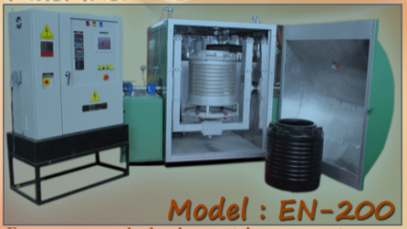
SAND MULLER

Supplier: METSONIC ENGINEERS PVT LTD
Specifications
Capacity | 75 kg.
Pan diameter (internal) X ht | 900 x 400 mm
Roller diameter X width | 400 x 90 mm
Motor | 3 hp 1440 rpm
Rotation | clockwise
Spindle rpm | 32
Mulling time | 4 to 5 minutes

