Computer Aided Manufacturing(CAM) Lab

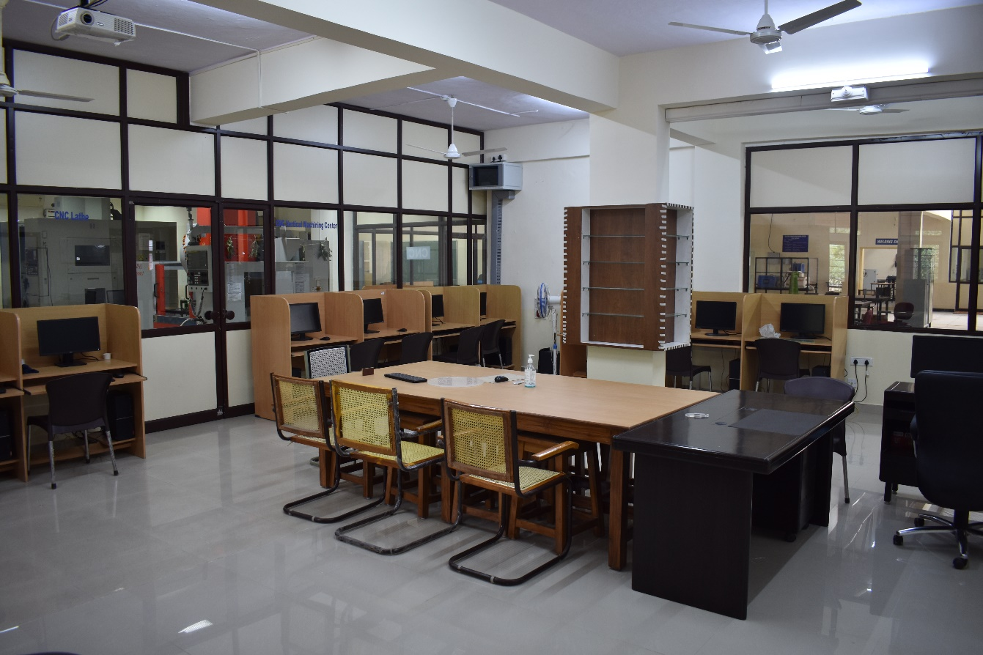

CNC VERTICAL MACHINING CENTER
Make : BRIDGEPORT (HARDINGE)
Model : GX 600
Control system : Fanuc 0i MD
Specifications:
Travels: X,Y,Z |  | 600x540x540mm
Working Surface |  | 750mm x 540mm
Control Type |  | Fanuc i-Series GX
Spindle Taper |  | No. 40
Spindle power |  | 15kw
Spindle Speed |  | 8,000 rpm
Tool Changer capacity |  | 20
Accuracy | Positioning | 0.01mm
 | Repeatability | 0.005mm
Feed rates max. | Cutting | 12m/min
 | Rapid &Jog | 30m/min
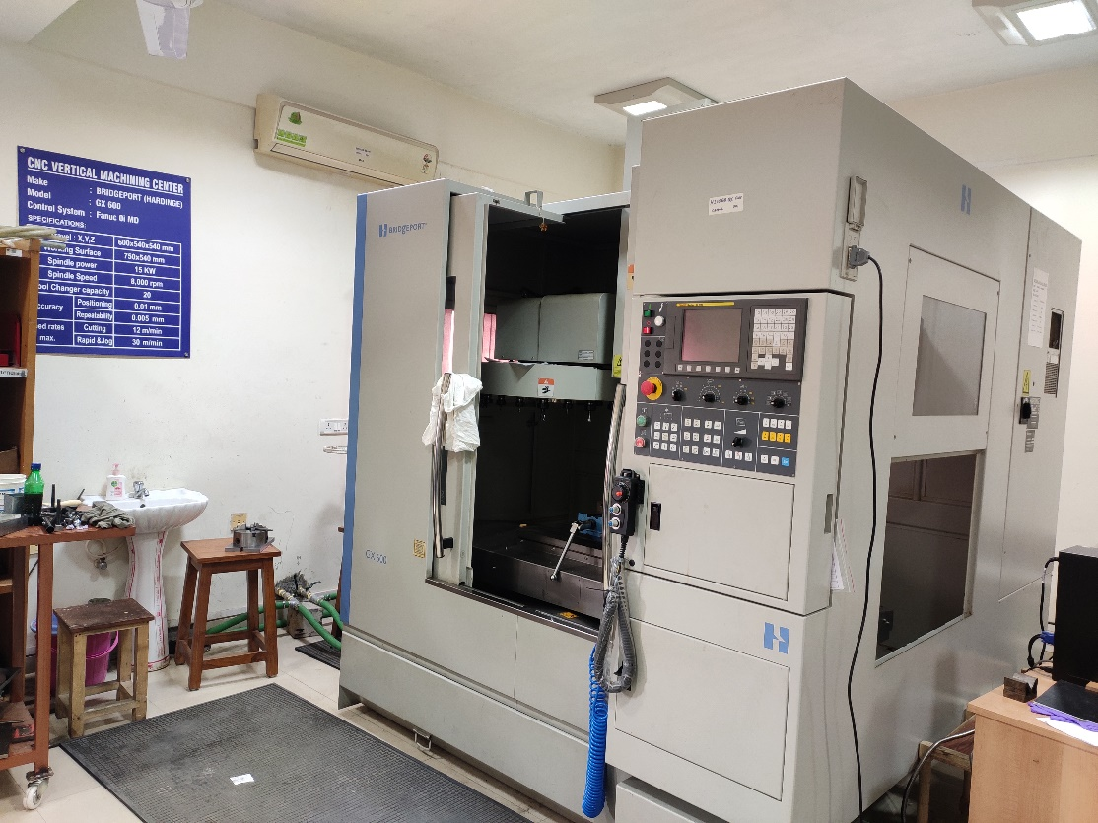

CNC VERTICAL MACHINING CENTRE
Make : BFW
Model : CHANDRA+
Control System : Fanuc OiMF +
Specifications:
Travel: X,Y,Z |  | 800 x 350 x 380 mm
Working Surface |  | 1060 x 315 mm
Spindle Power |  | 5.5 kW
Spindle Speed |  | 60 - 6000 rpm
Tool Changer Capacity |  | 20
Accuracy | Positioning | ± 0.010 mm
 | Repeatability | ± 0.005 mm
Feed Rates  Max. | Cutting | 1-5000 mm/min.
 | Rapid& Jog (X,Y) | 10,000 mm/min.
 | Rapid & Jog (Z) | 5000 mm/min.

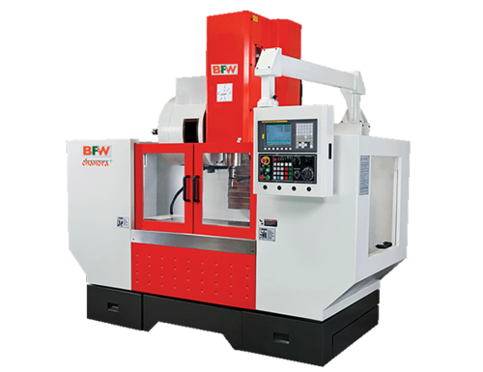

CNC LATHE MACHINE
Make : HMT-PRAGA
Model : PTC- 200
Control system : FANUC Oi-Mate
SPECIFICATIONS:
Swing diameter over Bed |  | ø250mm
Max.Turning Diameter |  | ø200mm
Max.Turning Length with Chuck |  | 200mm
Max.Turning Length without Chuck |  | 300mm
Spindle Speed |  | 100 – 4000rpm
No. of Tools |  | 8
Turning Tool Size |  | 20x20mm
Type of Bed |  | Inclined 30˚ to vertical
Traverse | X-axis | 110mm
 | Z-axis | 300mm
Feed Rates |  | 1 – 5000mm/min
Rapid Feed Rates | X-Axis | 18m/min
 | Z-axis | 30m/min
Positional | X-Axis | ±0.003mm
 | Z-axis | ±0.004mm
Repeatability | X-Axis | ±0.003mm
 | Z-axis | ±0.004mm
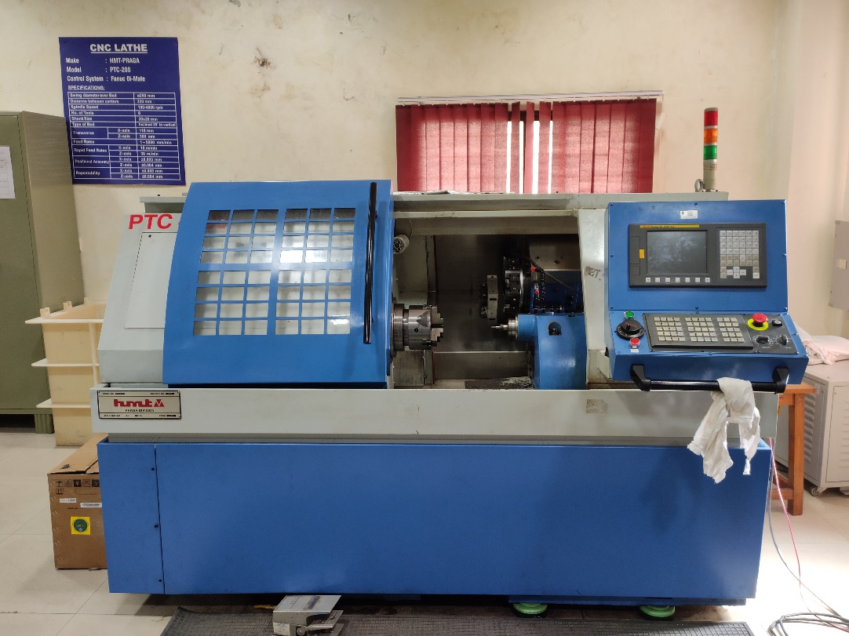

CNC TURNING CENTER –TRAINER
Make: MTAB Engineers Pvt. Ltd
Model: XLTURN

Specifications:

X- Axis Travel | 80 mm
Z- Axis Travel | 180 mm
Chuck Size | 100 mm
Maximum Turning Diameter | 32 mm
Maximum Turning Length | 120 mm
Distance between Centers from Spindle Face | 210 mm
Spindle Nose Taper | A2-3 / MT3
Spindle Speed Range | 150 - 3000 RPM
Spindle Motor Capacity | 1 HP
Number of Stations | 8
Control | Fanuc
Main Supply | Single phase, 110V/230 V, 50/60 Hz

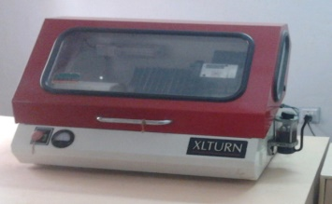

HIGH SPEED MICROMACHINING CENTER
Make: MicroMach, India
Model: PMC080
Specifications:
Stage Travel | X-axis | 100 mm
 | Y-axis | 100 mm
 | Z-axis | 100 mm
Mode of Operation |  | CNC
Accuracy |  | ± 2µm for stage
Resolution |  | 0.15 µm
Load Capacity |  | 15 kg on stage
Max. Spindle Speed |  | 80,000 RPM
Travel Speed |  | 0.01 – 20 mm/sec
Max. Torque |  | 11.9 N-cm
Support |  | Granite
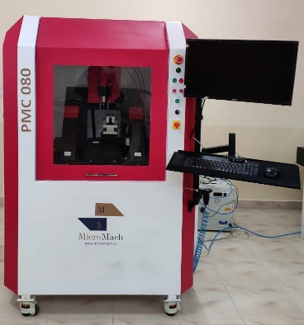

LATHE CUTTING FORCE DYNAMOMETER
Make: NK Instruments
Specifications:
3 Component Piezoelectric Based Cutting Force Measurement System( Fz, Fx, & Fy)
Cutting force Dynamometer Size | 109 x 80x 35 mm
Range: Fx , Fy & Fz direction | ± 4 kN,
Sensitivity | Fx: 3.7 pC/N, Fy: 7.8 pC/N, Fz – 7.8 pC/N.
Cable: | Connecting cable for 3-component sensors with V3 neg. connector - 3xBNC pos- 3 to 5 meter length
Multi-Channel Charge Amplifier | Industrial type Charge Amplifier, 3 channel , BNC, Range 15PC to 1,00,000 PC, Voltage Output:+/-10 V, Max Current Output+/- 5 mA, Output Impedance: 10 ohm
Data Acquisition System | Data Acquisition Hardware supporting 4 Channel Simultaneous Sampling, Input Range: ±1.25,±2.5,±5,±10 V, Sample Rate: 50.0/100 kS/s per Channel, Input BNC neg. Resolution: 24-Bit Anti-aliasing Filter, Interface: USB 2.0
Data Acquisition Software Data Acquisition & Analysis Software | Customized Standalone configuration based on Channel selection. Graphics Functions Measured data represented on one or more graphs Display as y(t), Display of numeric values Cursor function, Zoom function, Data Export with storing facility. Display of average value of data Min, Max value of data.

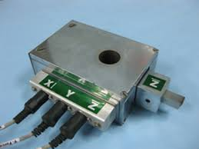
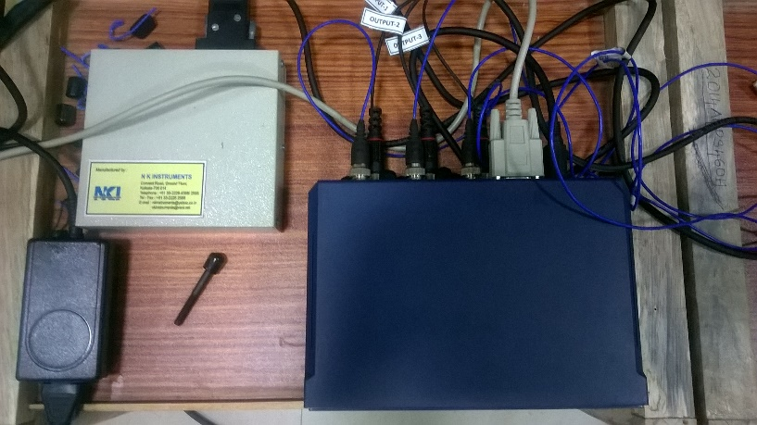

CNC MILLING, LATHE & DRILLING TOOL DYNAMOMETERS
Make: EMI Technologies
Specifications:
Drilling Tool Dynamometer (2 Forces – Thrust & Torque) With Signal conditioner for XY axis.
Sensor- | Strain gauge based two axis force sensor
Accuracy(Approx.) | ± 1 of full scale
Linearity(Approx.) | ± 1 of full scale
Excitation Voltage (Approx.) | 10V DC MAX
Display Type | Independent for each axis.
Range | 500 kg force in Thrust 20.0kgm force in Torque
USB data acquisition system  (2 Channel) | Resolution: 12-bit ADC, No of samples: 10K samples per sec. No of channels:8(single ended),4(differential ended)
Lathe Tool Dynamometer with Signal Conditioner for XYZ
Accuracy(Approx.) | ± 1 of full scale
Linearity(Approx.) | ± 1 of full scale
Excitation Voltage (Approx.) | 10V DC MAX
Display Type | Independent for each axis.
Range | 500 kg force in three direction
USB data acquisition system  (3 Channel) | Resolution:12 bit ADC, No of samples: 10K samples per sec. No of channels:8(single ended),4(differential ended)
Milling Tool Dynamometer With Signal conditioner for XYZ axis.
Sensor Size(Top) | 300mm X 300mm
Sensor | Stain gauge based three axis force sensor
Accuracy(Approx | ± 1 of full scale
Linearity(Approx) | :-:- ± 1 of full scale
Excitation Voltage (Approx) | 10V DC MAX
Display Type | Independent for each axis
Range | 500 kg force in three direction
USB data acquisition system  (3 Channel) | Resolution:12 bit ADC, No of samples: 10K samples per sec. No of channels:8(single ended),4(differential ended)

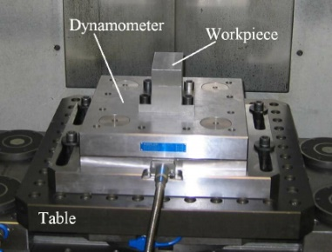

TOOL VIBRATION MEASUREMENT DEVICE
Make: PCB Piezotronics
Model: 356B21&482C05

Specifications:

Platinum Stock Products: Triaxial ICP® ACCELEROMETER
Sensitivity | (±10%)10 mV/g (1.02 mV/(m/s²))
Measurement Range | ±500 g pk (±4905 m/s² pk)
Electrical Connector | 8-36 4-Pin
Frequency Range (±5 %) (y or z axis) | 2 to 10000 Hz
Frequency Range (±5 %) (x axis) | 2 to 70 00 Hz
Resonant Frequency | ≥55 kHz
Broadband Resolution (1) | 0.004 g rms (0.04 m/s² rms)
Platinum Stock Products; 4-channel, line-powered, ICP® sensor signal conditioner
Channels | 4
Sensor Input Type(s) | ICP®
Output Range (Maximum) | ±10 V
Low Frequency Response (-5 %) | <0.1 Hz
High Frequency Response (-5 %) | >1000 kHz
Phase Response (at 1 kHz) | ±1 °
Cross Talk (maximum) | -72 dB
Fault/Bias Monitor/Meter (LED) | Open/Short/Overload
