Carpentry Section

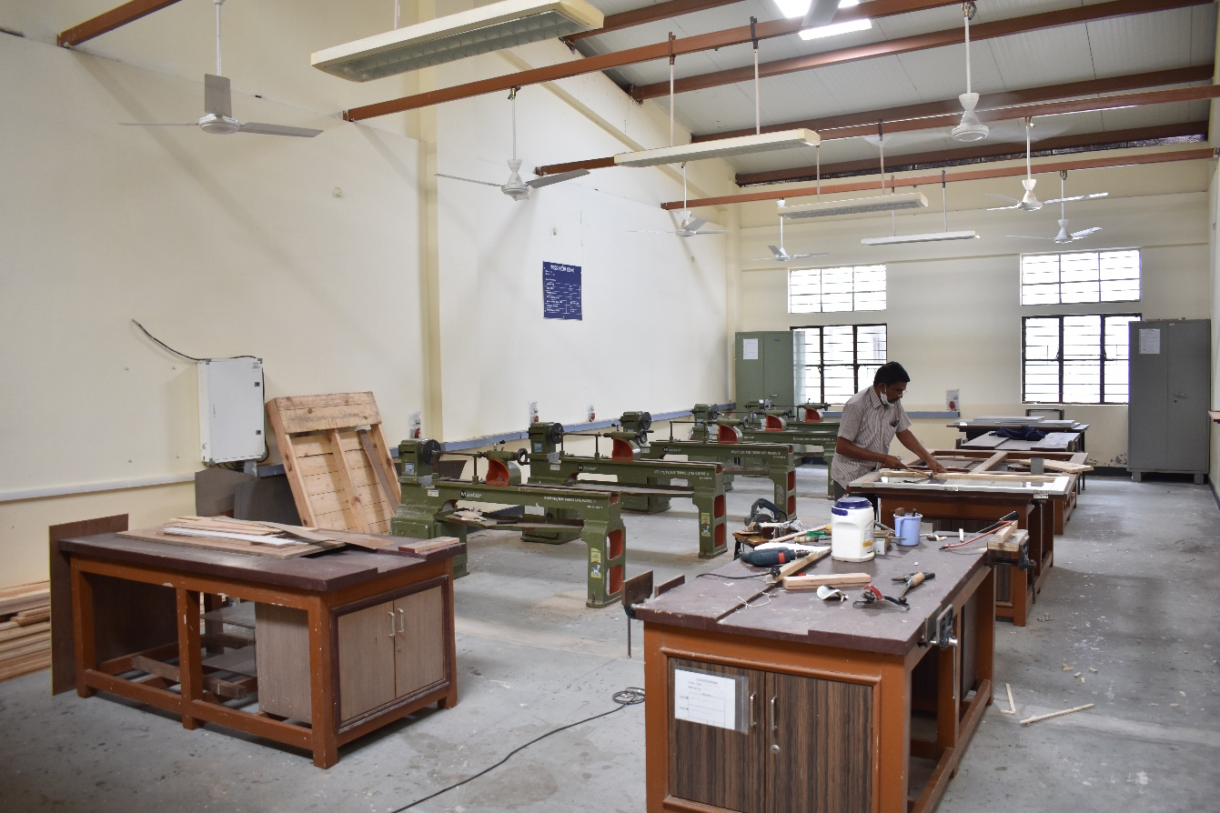

MULTIFUNCTION WOOD WORKING MACHINE

MAKE: JAI

MODEL: J-1010

Specifications:

Surfacing capacity | 10"
Max.planing width | 10"
Thicknessing capacity | 7"
Feeding speed-feet per minute | 21
Cutter block speed- RPM | 4000
Circular saw table size | 10"
Max.circular saw diameter | 12"
Power required - HP / RPM | 3/1440

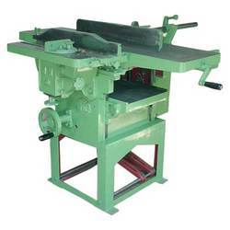

WOOD LATHE (5 NOS)

Make: JAI

Model: J 911

Specifications:

Length of bed | 54"
Width of bed | 8 ½"
Height of centers | 6½"
Admit between centers | 30"
Approx. spindle speed - RPM | 700 / 1400 / 2800
Face plate diameter | 7½"
Power required HP/RPM | 1 / 1440

