**Title of the Poster (Capitalize each word,** Times New Roman Font 14**)**

**Amol N. Nipate**,a Jarin Kumar,b ……… and Tarun Singha,* (Times New Roman Font 12)

aAffiliation/Institute/University, Place (Times New Roman Font 12)

bAffiliation/Institute/University, Place (Times New Roman Font 12)

E-mail*: abc@* (Times New Roman Font 12)

**Abstract:**

In this article we have reported ……………………………….. The details will be presented during the conference. We have developed a model for …………….

Times New Roman (Font 12, line spacing: single, spacing after para: 6 pt)

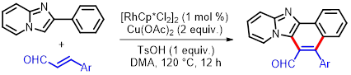

**Figure/Scheme**: Caption

**References and Notes:**

1. Author, A.; Author, B.; *Jounal*, **Year**, *Vol.*, Pages
2. Author, A.; Author, B.; *Jounal*, **Year**, *Vol.*, Pages

DO NOT EXCEED MORE THAN A PAGE (remove before submission)

DO NOT ALTER THE MARGINS