Advanced Machining Lab

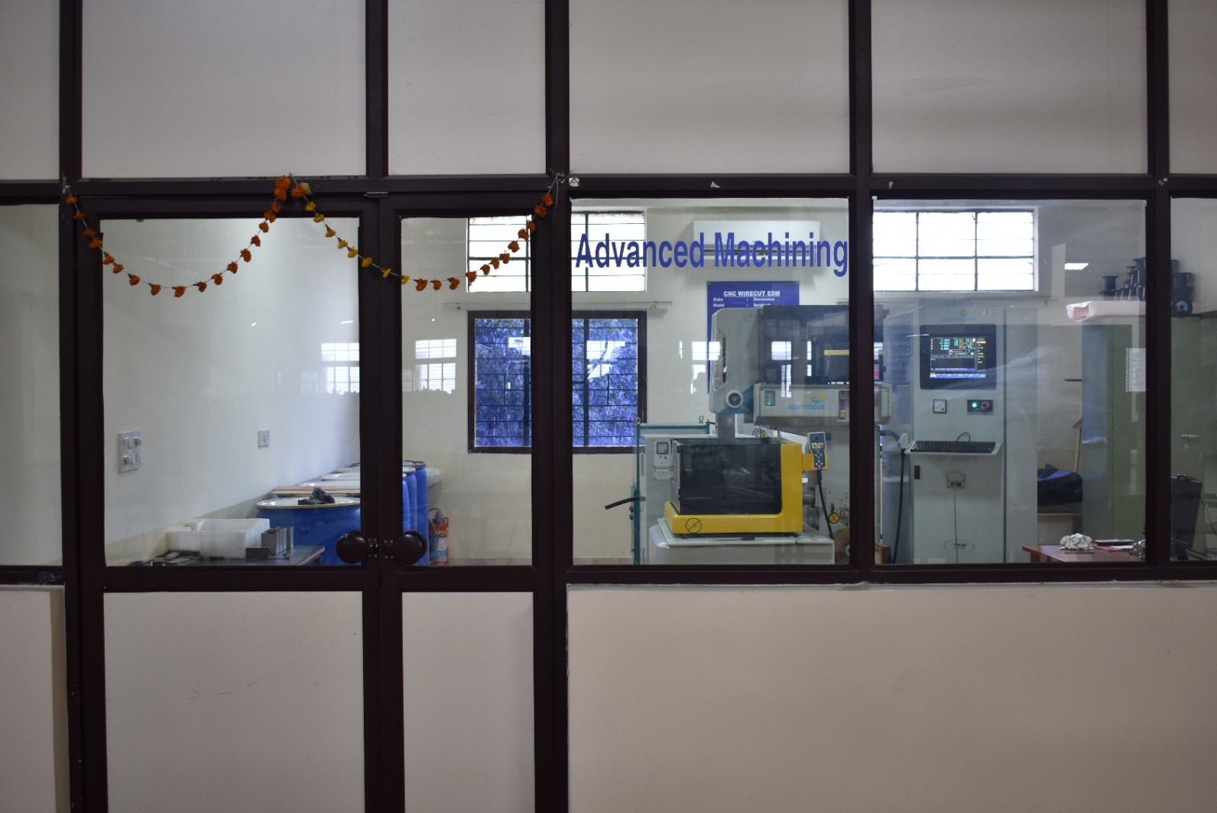

CNC WIRECUT EDM
Make : Electronica
Model : Sprintcut
Specifications:
Main table traverse (X,Y) | 300 mm x 400 mm
Aux. table traverse (u,v) | 80 x 80 mm
Max. work piece height | 200 mm
Taper | ± 30° over 50 mm
Max. JOG speed | 900 mm/min
Best surface finish | 0.8 µm
Wire electrode diameter | 0.25(std.), 0.15, 0.2 mm (opt.)
Resolution | 0.0005 mm
Least input increment | 0.001 mm
Capacity | 10 kVA
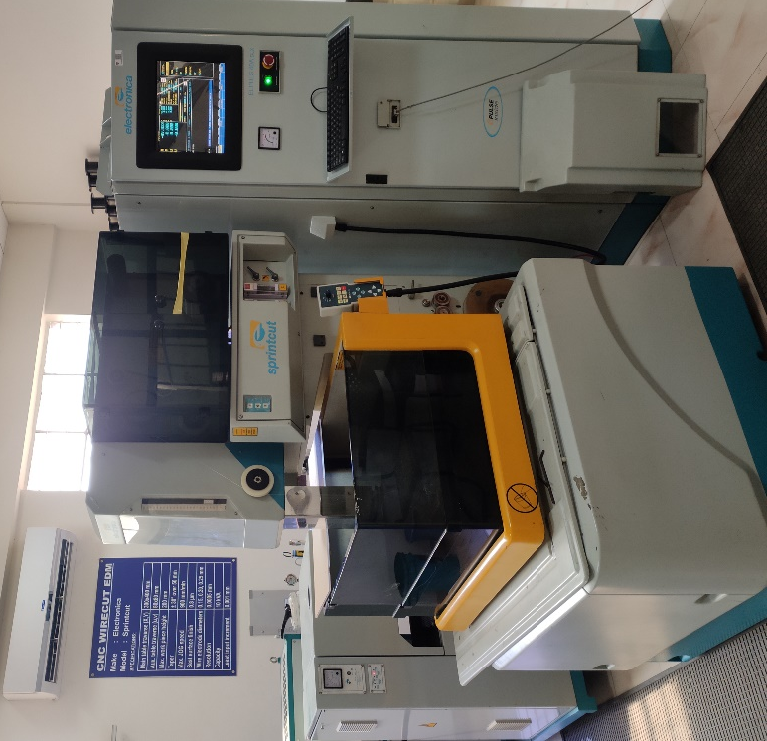

ELECTRO CHEMICAL MACHINING SYSTEM
(Table Top Model)

Make : METATECH Industries

Model : ELECTRO-M

Specifications

Tool Area | 300 mm² (10x30mm or 15x20mm)
Cross Head Stroke | 40mm
Supply | Single phase 230V. A.C
Electrical Output Rating | 0-100Amps and Voltage 0-25V DC
Tool Feed Rate | 0.2 to 1 mm/min
Machining Time | 0 to 1999seconds
